Simile – a comparison using the words __________ or ___________
Metaphor – a ____________________ not using like or as
Personification – giving __________ characteristics to __________ or non-living things
___________________________________________________________________________________

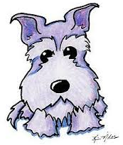
The Cookie Thief
Gretchen is my sweet little dog. She is small and gray. Her fur is as soft as a snuggly blanket. She loves to cuddle and play, but more than anything else Gretchen loves to eat people food! Her favorite food is cookies! She loves all kinds of cookies – peanut butter cookies, sugar cookies, chocolate chip cookies. She is a cookie monster always hungry for more sweet and delicious snacks.
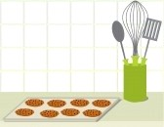
One day, my mom baked some cookies. Their scent begged Gretchen to eat them. The house was quiet. Gretchen was alone with the cookies. She was a little thief. She sneaked into the kitchen as quietly as a mouse. She sniffed the air. The cookies were waiting on the counter. But the counter was high. How could she reach them? She stood on her back legs, but she could not reach them. She jumped like a kangaroo. She could see the cookies, but she could not reach them.
Gretchen would not give up. She wanted those cookies more than anything else in the whole world. She looked around and made a plan. She pushed the trash can down. An avalanche of trash spilled onto the floor. Gretchen climbed on top of the trash can and stretched. She could almost reach the counter. She gathered all her strength and jumped again. She was on the countertop! The cookies were so close!
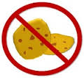
Just as she was about take a big bite of the delicious sweet cookies, the door opened suddenly. My mom screamed. Trash was covering the kitchen floor. The dog was standing on the kitchen counter over the plate of cookies like a guilty thief. The cookie monster tried to hide. But it was too late. Gretchen knew she was in big trouble. She was not going to get any cookies for a long, long time.
Underline the all the similes in the story. Circle the metaphors. Draw a box around the personification.

