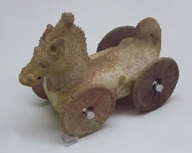
Do you think children who lived a thousand years ago had toys? Believe it or not, they did! Their toys were very simple compared to the toys that children play with today. Their toys were mostly handmade from things that were found in nature, like animal bones, stones, wood, or clay. The ancient Greeks and Romans played with rattles and dolls made from clay, and tops made from wood. Children in Greece and Egypt even played with stone yo-yo’s. The Egyptians also played with marbles made from stone. In Asia, children played with kites made of wood and cloth.
A small clay horse on wheels from Ancient Greece
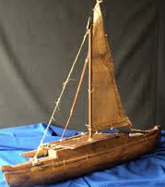
As history progressed, scientists began to discover and invent more materials to make toys. Not only could they use rocks, wood and clay, but they could also use cotton, leather and paper. Children began to play with picture alphabet cards, puzzles, and board games. Hand-carved wooden toys like rocking horses, toy soldiers and dolls were popular with children 200 years ago. Since it took time to hand-make wooden toys, only a small number could be sold at a time and they were expensive. Not every child could enjoy toys.
A toy sailboat made from wood and cloth
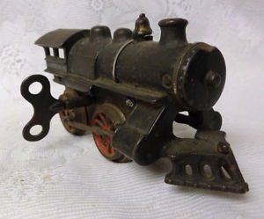
In the 1800s, the invention of machines changed how things were made, especially toys. Machines helped make toys faster than by hand and in larger numbers, so toys could be more affordable. They also helped to make toy parts from metals like aluminum, tin, and iron. For example, toy trains had wind-up tools made from tin so they could move. Machine-made toys became were very popular among toy makers and children.
A wind-up toy train
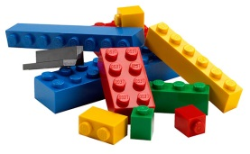
Another important type of material used to make toys is plastic. The first plastic was invented in 1870. Plastic changed the way many toys were made. It was cheap and could be easily molded into all kinds of shapes and colors. The plastic that most toys are made from today is called polystyrene. It was invented in the late 1920s. It is strong and can be stretched and shaped into different things. Some of the toys that were introduced at this time were Lego blocks and Mr. Potato Head. Have you ever played with these toys?
Legos are made from plastic, like most modern toys.
Toys today are made from stronger and safer types of materials than in the past. Many advances in science, technology, and engineering have changed the kinds of toys children play with. Today many toys include electronic parts that allow them to light up and make sounds. Even with all our differences, some toys we play with today – like puzzles or blocks -- are similar to the toys of the past.

