Type | Visual | Definition | Examples
Person vs. Self | 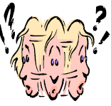 | _____________ conflict:  A struggle between the character and his/her own conscience. | - A woman is tempted to steal from her boss to feed her family.  - A boy is torn between skipping class with his friends or taking a test in a class he is failing.
Person vs. Nature | 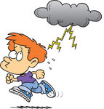 | _____________ conflict:  A struggle between the character and elements of nature that he/she cannot control. | - A family is trapped in a snowstorm.  - A man is dying because of a disease.
Person vs. Person | 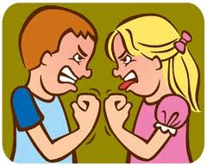 | _____________ conflict:  A struggle, mental or physical, between two characters in the story. | - A husband and wife argue about how to spend their money.  - A boss fires an employee.
Person vs. Society |  | _____________ conflict  A struggle between the character and the rules or laws of the society where he/she lives. | - A child breaks the rules at home and is grounded by her parents.  - A woman is speeding and runs a red light.  - A man stands up for what he thinks is right, even though no one else agrees with him.

